
INDIVIDUAL ASSIGNMENT COVERSHEET
COMP600 ITPM & COMP720 ITPP Assignment 2 (due 19th October 2018, 5pm)
Student ID  16945724 | First Name  Nikkolas | Surname  Diehl
Lecturer
Ramesh Lal

Lab/Tutorial class
IT Project Management – COMP600 – Stream 52

Please read the following and place an X next to each statement to indicate your understanding:
I understand it is my responsibility to keep a copy of my assignment. | X
I have signed and read the Student’s Statement below. | X
I understand that a software program (Turnitin) that detects plagiarism and copying may be used on my assignment. | X
Plagiarism and Dishonesty are methods of cheating for the purposes of General Academic Regulations (GAR) http://www.aut.ac.nz/students/regulations.html
Student’s Statement: This assessment is entirely my own work and has not been submitted in any other course of study. I will submit a copy of this assessment to Turnitin, if required. In this assessment I have acknowledged, to the best of my ability
- The source of direct quotes from the work of others.
- The ideas of others (includes work from private or professional services, past assessments, other students, books, journals, cut/paste from internet sites and/or other materials).
- The source of diagrams.
Signature:___________________________________________ Date: _________________________
The information on this form is collected for the primary purpose of submitting your assignment for assessment. Other purposes of collection include receiving your acknowledgement of plagiarism polices and attending to administrative matters. If you choose not to complete all questions on this form, it may not be possible for the Faculty of Design and Creative Technologies to accept your assignment.
ASSIGNMENT #2 (100 marks)
Contribution to final marks: 30%
Must get a minimum 35/100 marks in this assignment to get an overall pass for this paper

Submission Requirements:
- This is an individual assignment. The cover page must have your ID number and Name (in full)
- Please use 1.5-line spacing and 12 font (no hand written assignment will be marked)
- In the footer include the page number.
- Hard-copy submissions due
- BCIS students must only do the first four (4) tasks (100 marks). Task 5 is an additional question for Graduate Diploma students, must do all five questions (125 marks).

A Case Study for Tasks 1 and 2

Manage Your Health, Inc. (MYH) is listed in the Fortune 500 Company that provides a variety of healthcare service across the globe. They have 25,000 full-time and 8,000 part-time employees. A study found that MYH, Inc. pays 45% more than the industry average for their employee healthcare premiums, due to the poor health of its employees. Therefore, the company has planned to provide a web application that provides online functionalities to help their employees enrol and manage their health-management and recreational programs. This application will have the following capabilities.
- Allow employees to register for company-sponsored recreational programs such as soccer, netball, bowling, jogging and walking etc.
- Allow employees to register for company-sponsored classes and programs to help them manage their weight, reduce stress, and stop smoking etc.
- Track employees’ involvement in these recreational and health-management programs
- Over incentives for people to join the programs and do well in them

Project’s financial information
The project is expected to cost the company $950,000 for the web application development and $550,000 for web and database servers. The project is expected to take 6 months to complete. They believe that this application will help improve their employees’ health after a year of its rollout so that the company can negotiate lower healthy insurance premiums, providing a net saving of at $300 per employee per year for full-time employees and $150 per employee per year for part-time employees over next five years. The company does not expect any savings in employee healthcare premiums for the first two years when the application will be up and running. A yearly budget of $300,000 has been set aside for the next five years for system maintenance. A new role “Application Support Engineer” has been created with the responsibility to work with the software engineering team to develop the application and to provide on-going application support after the roll out of the application. This role will cost the company $120,000 with a 5% yearly increase in the annual salary. Assume that the discount rate is 6%.
Task 1: Business case financial anaylsis (15 marks)

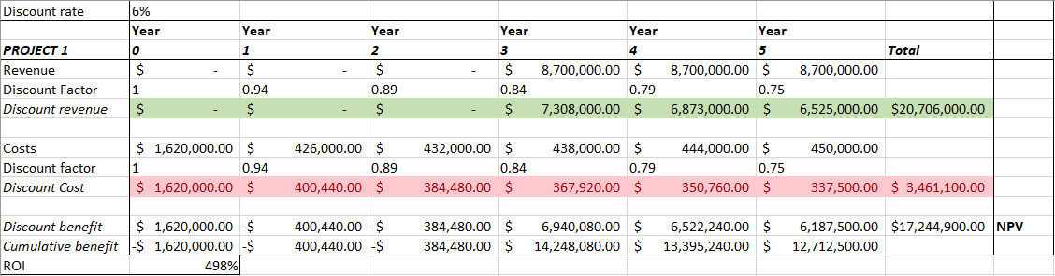
  - You are required to prepare a financial analysis up to year 5 using the table provided below for the MYH’s project in order to find the return of investment (ROI) and payback period of the project based on the financial information provided. (7 marks)
Yearly saving: ($300*25000)+($150*8000) = $8,700,000

  - Calculate the ROI of the project (3 marks)
- ROI = 498%

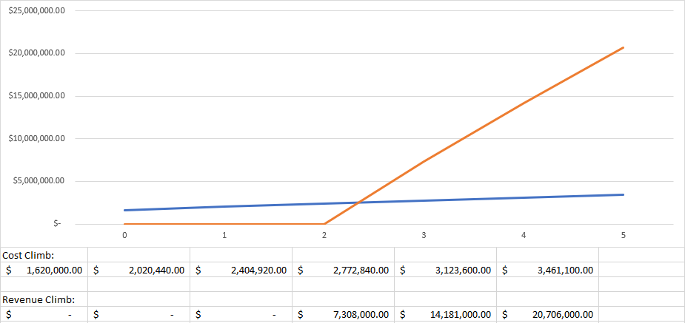
  - Calculate the payback period of the project (3 marks)
- Assuming that the company does not make any savings for the first two years after deployement, then the payback year starts in the second year and by the third year, the project will be fully paid back

  - Justify if the proposed project is worthehile undertaking (2 marks)
- The proposed project is very worthwhile as the payback year is only 2 and a bit years into the 5 year project and the revenue saved is huge with a very large 498% ROI

Task 2: Project cost control (25 marks)

You are required to control the budget for the above MYH’s project.

  - What is the total budget at completion (BAC) for the project? (3 marks)
- $1,500,000

  - Assume that the work for the first month is completed in the project. The following information has been provided as a result of work done so far.

Plan Value (PV) = $160, 000
Earned Value (EV) = $120, 000
Actual Cost (AC) = $180, 000

Answer the following questions 2.2.1 - 2.2.5 (must show all the working).

    - Explain a likely reason for the difference between PV and AC for the first month of this project. (4 marks)
- Problems mean the project is costing more than planned which is over budget or taking longer than planned which is behind schedule. If the cost variance is negative, it means that actually performing the work cost more than planned, and if the CV is positive, it means the actual performing of work cost less than planned.

    - Calculate the cost variance (CV) and the cost performance index (CPI) for the first month in this project? Is the project under or over budget? (6 marks)
- (CV = EV – AC) – $120,000-$180,000 = -$60,000.
- (CPI = (EV/AC)*100) – ($120,000/$180,000)*100 = 67%
- The negative CV means performing the actual work in the first month cost more than planned, and if the CPI is less than 100%, which it is it means that the project is over budget for the first month.
- All of this is expected due to no savings being made in the first 2 years AFTER the product goes live.

    - Calculate the schedule variance (SV) and the schedule performance index (SPI) for the first month in this project? Is the project ahead of or behind schedule? (6 marks)
- (SV = EV-PV) – $120,000-$160,000 = -$40,000
- (SPI = (EV/PV)*100) – ($120,000/$160, 000)*100 = 75%
- The SV being negative means that performing the actual work took longer than expected for the first month.
- The SPI being lower than 100% means the project is behind schedule for the first month.

    - Calculate the new estimate at completion (EAC) for this project after the completion of first month’s work. (3 marks)
- (EAC = (BAC/CPI)*100) – ($1,500,000/67)*100 = $2,238,806

    - Calcuate how long it will now take to finish this project after working on the project for a month. (3 marks)
- (New estimated time=(Original time/SPI)* 100) – (6 months/75)*100 = 8 months

Task 3: Project schedule development (30 marks)

The Table shown below provides the activities (A to L) and their three point estimates for an Auckland city IT infrastructure (LAN Network) project.

Task | Predecessor | Optimistic duration | Most Likely duration | Pessimistic duration | Task effort
A | - | 15 | 17 | 30 | (15+4*(17)+30)/6 = 19
B | - | 15 | 13 | 25 | (15+4*(13)+25)/6 = 15
C | A | 20 | 22 | 35 | (20+4*(22)+35)/6 = 24
D | A | 10 | 15 | 30 | (10+4*(15)+30)/6 = 17
E | C | 10 | 7 | 15 | (10+4*(7)+15)/6 = 9
F | D | 15 | 10 | 20 | (15+4*(10)+20)/6 = 13
G | B | 5 | 5 | 10 | (5+4*(5)+10)/6 = 6
H | B | 5 | 5 | 10 | (5+4*(5)+10)/6 = 6
I | E,F, G | 5 | 5 | 10 | (5+4*(5)+10)/6 = 6
J | H | 3 | 2 | 17 | (3+4*(2)+17)/6 = 5
K | J | 5 | 4 | 12 | (5+4*(4)+12)/6 = 6
L | I, K | 5 | 3 | 10 | (5+4*(3)+10)/6 = 5

  - Complete the PERT estimation to show the duration of each activity. (8 marks)
- (Optimistic time + 4 * most likely time + pessimistic time)/6
  - Draw the network (AOA) diagram to show the order in which all the activities will be undertaken in this project. The diagram must be clearly labelled. (6 marks)
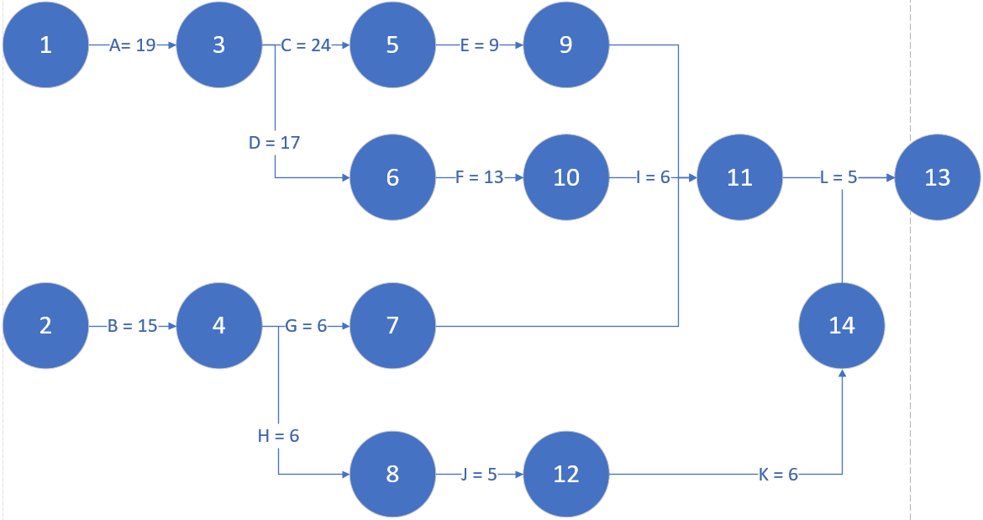

  - List all the possible paths for this project with their total durations. (5 marks)
- Path 1: A,C,E,I,L (Length = 19+24+9+6+5 = 63)
- Path 2: A,D,F,I,L (Length = 19+17+13+6+5 = 60)
- Path 3: C,E,I,L (Length = 24+9+6+5 = 44)
- Path 4: D,F,I,L (Length = 17+13+6+5 = 41)
- Path 5: B,G,I,L (Length = 15+6+6+5 = 32)
- Path 6: B,H,J,K,L (Length = 15+6+5+6+5 = 37)
- Path 7: G,I,L (Length = 6+6+5 = 17)
- Path 8: H,J,K,L (Length = 6+5+6+5 = 22)
  - Clearly identify and briefly explain the critical path for this project. (7 marks)
- Critical path is the path with the longest time and thus determins the earliest time the project can be finished. The critical path in this network diagram is path 1 (A,C,E,I,L) which is 63 days long. This path must be completed without delays so as to not halt the progress of the project
  - This network is expected to be up and running within 4 months from the time the work on the project is started. Does this opening date appear feasible? (4 marks)
- 63 days ≈ 2 months. The project will easily be completed within that time assuming the different paths along the network are done in parallel.

Task 4: Project selection (30 marks)

You are required to perform some analysis to help identify the order in which the projects will be undertaken from the available four projects.

  - Use the information below to create a table that must show the weighted score and priority for each project. (7 marks)
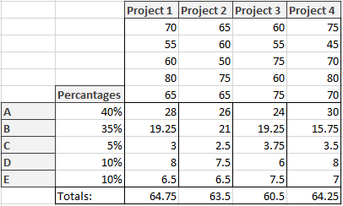
The factors that impact the success of a project include (a) the availability of at least 4 senior software engineers with local development experiences) (40%); (b) a senior product manager (on-site customer) (35%); (c) interest from sales & marketing team (5%); (d) availability of an agile tester (10%); and (e) a clear product backlog (10%). Table below provides the scores based on these factors for each project.
Project / Criteria | a | b | c | d | e
Project 1 | 70 | 55 | 60 | 80 | 65
Project 2 | 65 | 60 | 50 | 75 | 65
Project 3 | 60 | 55 | 75 | 60 | 75
Project 4 | 75 | 45 | 70 | 80 | 70

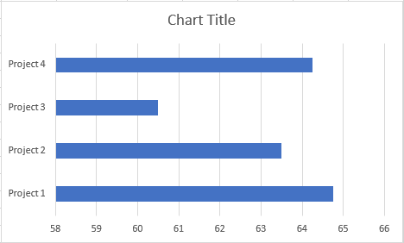
  - Explain the order in which these 4 project should be undertaken. (3 marks)
The higher the weighted score, the better and higher priority the project. This means that project 1 should be started and completed first.

  - Based on the information provided below, perform a quantitative risk analysis using a decision tree diagram to calculate expected monetary value (EMV) and contingencey reserve for each project. (10 marks)
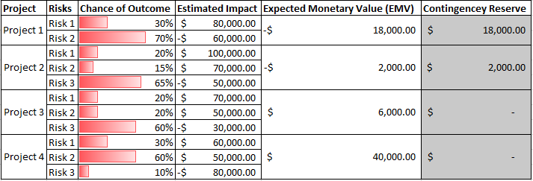
  - Explain the contingency reserve for each project (10 marks)
- In project 1, the expected monetary value is in the negative due to the estimated impact. Because of this, the project needs a larger budget to balance out the negative. A contingencey reserve of $18,000 is needed to do this.
- In project 2, the expected monetary value is also in the negative due to the estimated impact. Because of this, the project also needs a larger budget to balance out the negative. A contingencey reserve of $2000 is needed to do this.
- In project 3 however, the expected monetary value is actually in the positive meaning the project is not using up all of the original budget. This means that $6000 is left over after the project is done. This means $0 is needed as a contingencey reserve.
- In project 4, same as project 3, the expected monetary value is positive so $0 is needed for a contingencey reserve.

